mRNA Covid-19 Vaccines
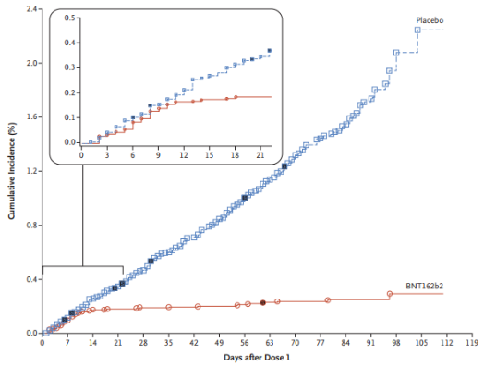
Vaccine Efficacy
Context: mRNA vaccines rely on novel technology not extensively used prior to the Covid-19 pandemic.
Current: Two trials that randomized 43,548¹ and 30,420² patients to vaccine or placebo found ~95% efficacy for Covid-19 prevention across multiple subgroups in both trials.
Cutting Edge: Physician leadership partnering with community leaders will be critical for educating patients and communities about the importance of vaccination. Many resources are available to help facilitate these conversations.³

Vaccine Safety
Context: Public concerns about potential adverse events related to Covid-19 vaccination are prevalent.
Current: These Efficacy trials above also examined vaccine safety.^{1,2} Most reactions were mild (grade 1/2).
Cutting Edge: Symptoms that last >48 hrs after vaccination, begin >7 days after, or include or loss of taste and smell should trigger evaluation for actual disease. Isolating while symptomatic is probably prudent.

Herd Immunity
Context: Natural immunity following Covid-19 infection is variable with unknown durability. Tools are available to help providers encourage patients and community members to pursue vaccination.³
Current: With vaccine efficacy of ~90%, herd immunity requires vaccinating 60% of the population if the R₀ is 2.0 (meaning each new case infects 2 other people). This is >195 million people in the US. If the R₀ is 3, 80% of the population needs to be vaccinated to achieve herd immunity.⁴
Cutting Edge: Continued physical isolation and masking can effectively reduce the R₀, thus lowering the threshold to achieve herd immunity in addition to the direct protection that masks provide.

Mutant Covid Strains
Context: Mutant strains of Covid are emerging. Vaccine efficacy against these strains is unproven.
Current: Mutants first identified in the United Kingdom and South Africa have been detected in the US.
Cutting Edge: Because the mRNA vaccines use the entire spike protein to generate an immune response, they may still protect against mutant strains.⁴ Preliminary evidence suggests good protection against the UK strain but reduced protection against the South African strain.

- Fernando P Polack, et al. Safety and Efficacy of the BNT162b2 mRNA Covid-19 Vaccine. N Engl J Med 2020; 383:2603-2615.
- Lindsey R Baden, et al. Efficacy and Safety of the mRNA-1273 Sars-CoV-2 Vaccine. N Engl J Med. Published on-line December 2020.
- CDC Covid-19 Vaccination Communication Toolkit. Available online at: https://www.cdc.gov/vaccines/covid-19/health-systems-communication-toolkit.html#faqs
- Frederick Southwick. Educational content create for Coursera, available online at: https://www.youtube.com/watch?v=P3wBVs-s7jI&feature=youtu.be and https://www.youtube.com/watch?v=P3wBVs-s7jI&feature=youtu.be

